***2. Semester:   
7 Controlling a steppermotor***

**Ayman Miri &  
 Christian Steffen**

**Controlling a steppermotor**

**Project planning:**

**Contents:**

1. **Materiallist**
2. **Softwares**
3. **Timeplanning**
4. **Theory**
   1. **Run a Stepmotor**
   2. **Circuit plans**
   3. **Program**
5. **Building the case**
6. **Look**
7. **Problemsolving**
8. **Sources**

1. **Materiallist:**

|  |  |  |
| --- | --- | --- |
| Equipment: | Type: | x |
| Arduino Uno |  | 1 |
| Stepping Motor | SM-17HS4023 | 1 |
| Driver | LM-298_H_Bridge | 1 |
| Power-supply | MW MB10EU  12V | 1A | 12W max. | 1 |
| USB cable | Typ B | 1 |
| Jumper cable | Typ: Male/Male | x |
| Jumper cable | Typ: Female/Male | x |
| Button | Typ: Push-Button | 5 |
| OLED-Display | ADA938 OLED 128x64 | 1 |
| Resistances | 10k Ohm | 5 |

1. **Software:**

|  |  |
| --- | --- |
| Arduino | V: 1.8.13 |
| Eagle | V: 9.6.2 |
| Draw.io |  |
| Fusion360 |  |
| Word |  |

1. **Timeplanning:**

|  |  |
| --- | --- |
| 28.02.2022 | Preparation of materiallist |
| 07.03.2022 | Discussion over the material |
| 14.03.2022 | Clarify usage of the materials |
| 21.03.2022 | Plan the circuit & writing program |
| 28.03.2022 | Plan the circuit & writing program |
| 25.04.2022 | Program |
| 02.05.2022 | Program |
| 16.05.2022 | Program |
| 30.05.2022 | 3D printing & finish assembling |
| 13.06.2022 | Write report |
| 20.06.2022 | Discussion over the project & report |
| 27.06.2022 | Presentation |

1. **Theory:**

**IV.a Run a stepmotor:**

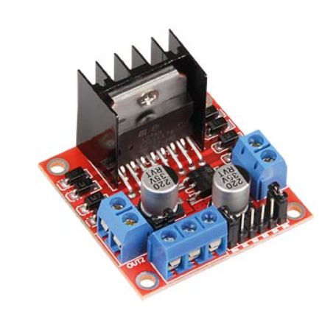First of all we need to know how we can control the steppermotor. We use there a L289N H-Bridge. This is the driver which is connected with a 12V supply

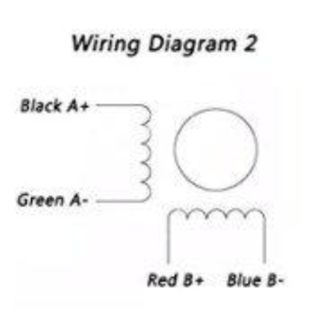Every coil of the motor has two connection pins. In this case A+ & A- and B+ & B-.

So we want to control those coils with our Arduino outputs. If we can control the coils, we can control the movement.

A steppermotor has got the function to move precisely

in single steps. We can divide a single 360° circular movement in 200 steps. Every step has its own logic, that we programmed in Arduino.

Ein Bild, das Tisch enthält.

We have here the order of the signals we must use to turn right. We see on the left side the order of the motorpins and how to do 4 steps, with the digital signal “High” and “Low”. To do 8 steps we just repeat the order. We are able to do many steps, in a certain speed and direction with our program.

**IV.b Circuit plans:**

**Arduino Uno connecting plan:**

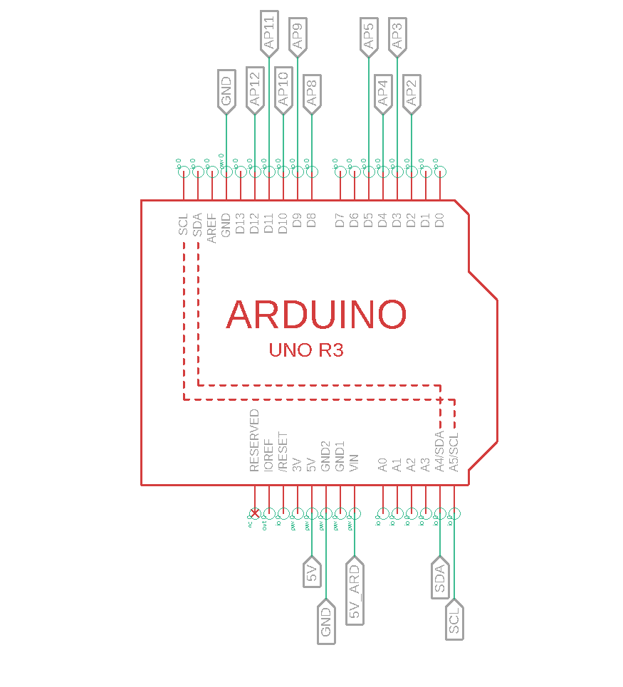

|  |  |
| --- | --- |
| Powersupply: | 5V_ARD |
| Supply for components: | 5V (intern Arduino) |
| Ground | GND |
| AP# | Arduino Pin Nr. |

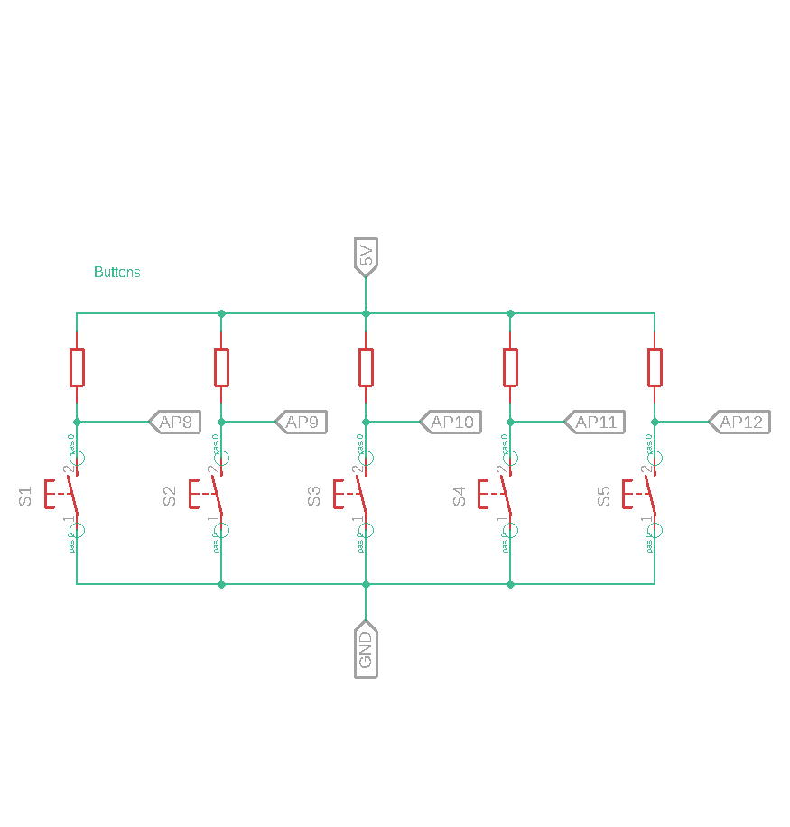**Buttons Connecting plan:**

**Resistances:** 5x 10k Ohm

|  |  |
| --- | --- |
| Supply | 5V (intern Arduino) |
| Ground | GND |
| AP# | Arduino Pin Nr. |

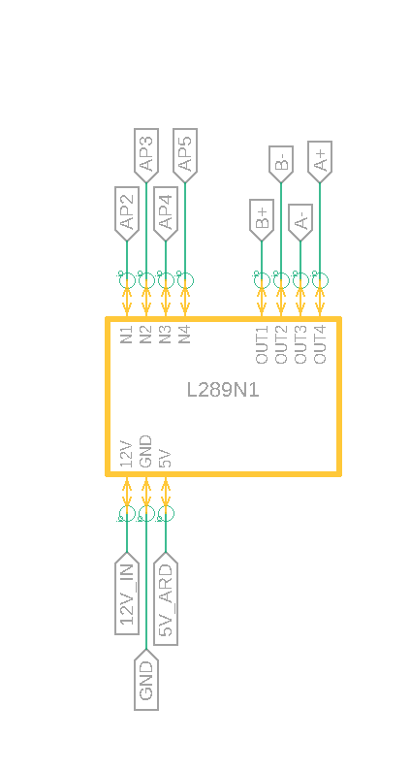**L289N1 connecting plan:**

|  |  |
| --- | --- |
| Supply | 12V |
| Supply | 5V  (intern Driver) |
| Ground | GND |
| AP# | Arduino Pin Nr. |
| Motor Pin | A+ |
| Motor Pin | A- |
| Motor Pin | B+ |
| Motor Pin | B- |

**Oled Display connecting plan:**

|  |  |
| --- | --- |
| Supply | 5V  (intern Arduino) |
| Ground | GND |
| Data | SDA |
| CLK | SCL |

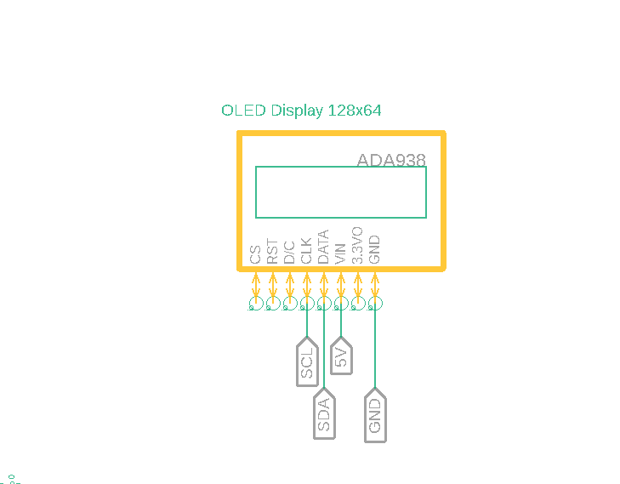

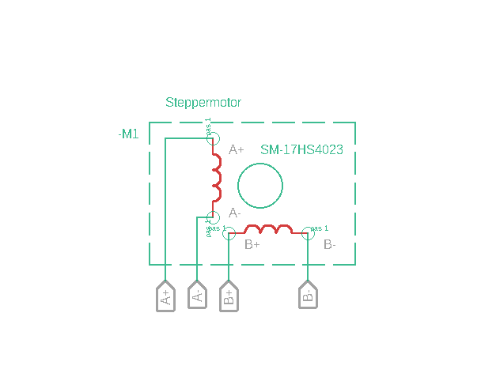

**Steppermotor connecting plan:**

|  |  |
| --- | --- |
| Motorpins: | A+ |
|  | A- |
|  | B+ |
|  | B- |

**Wiring:**

We used a the Arduino Uno here for getting control of the circuit. 5 buttons with pull-up resistances are our inputs. We used the SDA & SCL outputs for the OLED-Display and 4 digitalw outputs for controlling the L298N which manages the steppermotor.

1. **Theory**

**IV.c Program:**

Ein Bild, das Text, Elektronik enthält.

1. **Building the case**

We built our own case for our circuit.

We have 5 buttons, one OLED-Display, a steppermotor, a driver   
and the Arduino Uno to put in the case.

We made a model in Fusion 3D to print a 3D model of our case. It‘s divided in 2 parts: one top element, and the bottom lid. So we can easily open it again.

We had there a pair of complications in printing and some measure issues, we needed fix it and print it several times.

In the end we fixed the L298N, the Arduino Uno and the steppermotor with screws in the case.

The OLED, the circuit board with the buttons are perfectly fitting in the top, so there is no need for screws or more fixture.

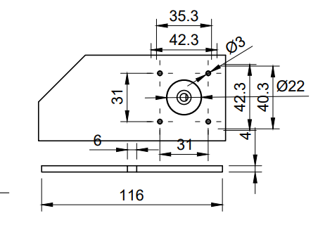Ein Bild, das Text enthält.

Steppermotor

1. **Final Look**

Ein Bild, das Text, Elektronik enthält.
In the inside of the top of the case we mounted the OLED, the button circuit board and the steppermotor.

**OLED-Display**

Picture 1 / Top case inside

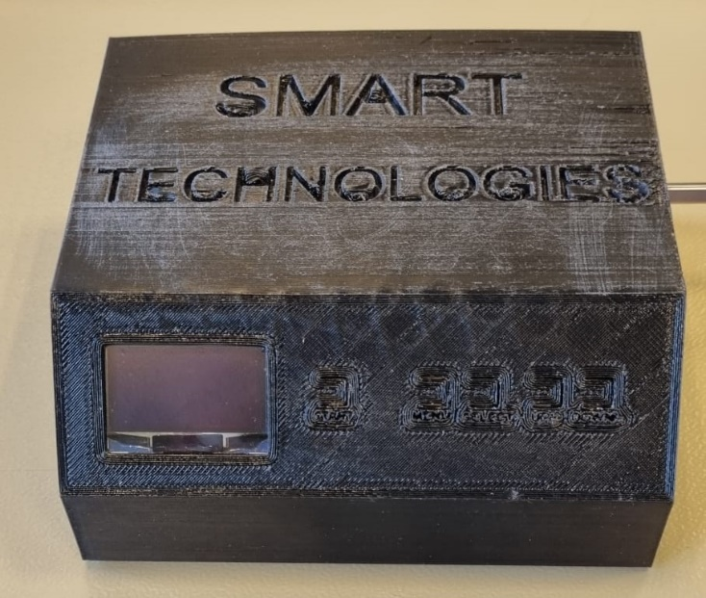Also we printed some words on the case, but for the buttons it didn’t work so well.

Buttons

Picture 2 / Top case outside

Buttons

**OLED-Display**

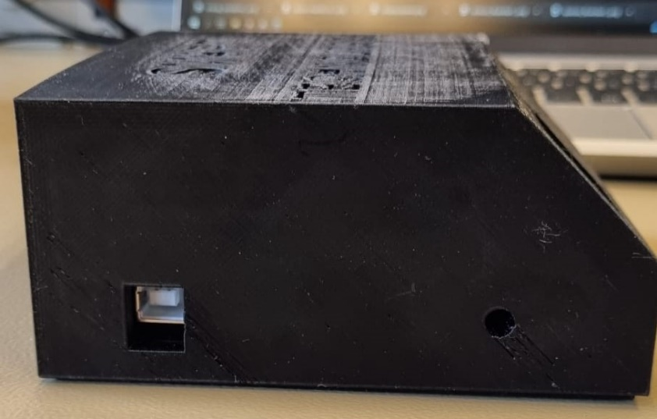

Picture 3 / Left side case

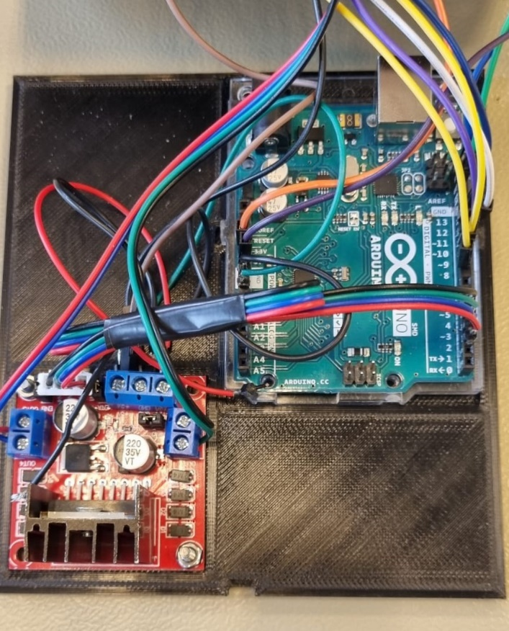On the left side we have the input for programming the Arduino with the USB typ B and in the right of this side we have a hole for the supply of the Arduino but actually we don’t use it. It’s just for maintenance. It would be necessary if the 5V output of the driver doesn’t work.

Supply (maintenance)

USB

On the bottom lid the driver and the Arduino are fixed. Because the case is not that high, we needed to get enough room for them. On the left side from the Arduino is the OLED-Display and his wiring. On the right side of the L298N is the room for the steppermotor and his wiring.

Arduino

The bottom lid is not fixed actually so we can easily open it with a screwdriver with the small hole at the bottom.

Open

L298N

Picture 4 / Bottom plate case

1. **Problemsolving & Maintenance**
2. **Sources**

<https://forum.digikey.com/t/how-to-drive-a-stepper-motor/13412>

<http://www.piclist.com/techref/piclist/jal/drivingbipolarsteppermotors.htm>

<https://www.instructables.com/Controlling-Bipolar-Stepper-Motors-with-Arduino-wi/>

<http://www.datasheetcafe.com/17hs4023-datasheet-stepper-motor/>

<https://www.sparkfun.com/datasheets/Robotics/L298_H_Bridge.pdf>

<https://www.manualslib.com/manual/1208079/Arduino-Uno.html>

<https://github.com/Ayman628/Seconde_semester>